**BOOK BANK SYSTEM**

**AIM:**

To Design ,Implement and Test the BOOK BANKSYSTEM described in the given problem statement

**PROBLEM STATEMENT:**

The process of members registering and purchasing books from the book bank are described sequentially through following steps:

First the member registers himself if he was new to the book bank. Old members will directly select old member button.They select their corresponding year. After selecting the year they fill the necessary details and select the book and he will be directed towards administrator. The administrator will verify the status and issue the book.

The book bank management system is a software in which a member can register themselves and then he can borrow books from the book bank. It mainly concentrates on providing books for engineering students. This system would be used by members who are students of any college to check the availability of the books and borrow the books, and then the databases are updated. The purpose of this document is to analyze and elaborate on the high-level needs and features of the book bank management system. It also tells the usability, reliability defined in use case specification.

**USE CASE DIAGRAM**

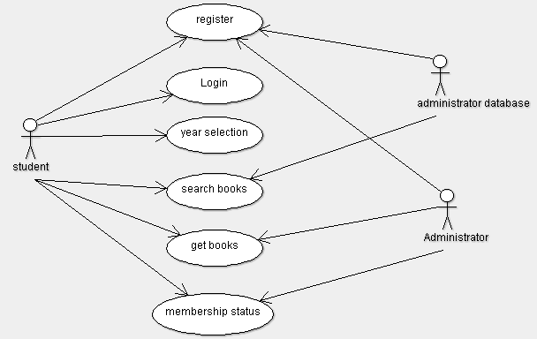

**CLASS DIAGRAM**

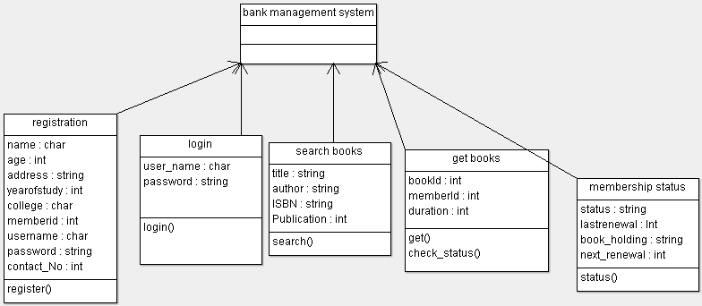

**SEQUENCE DIAGRAM:**

**Registration**

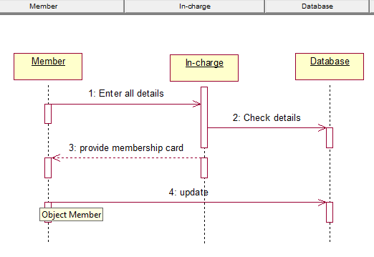

**Borrow Books**

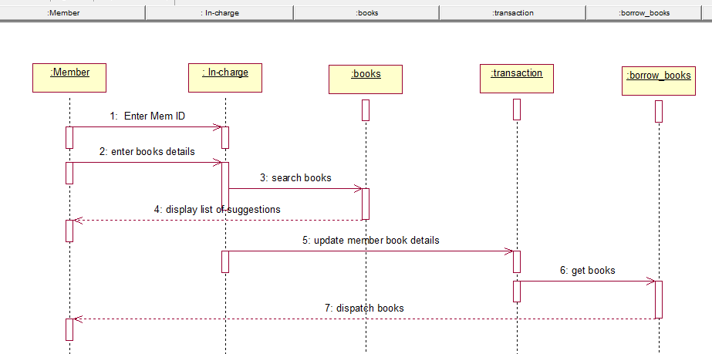

**ACTIVITY DIAGRAM**

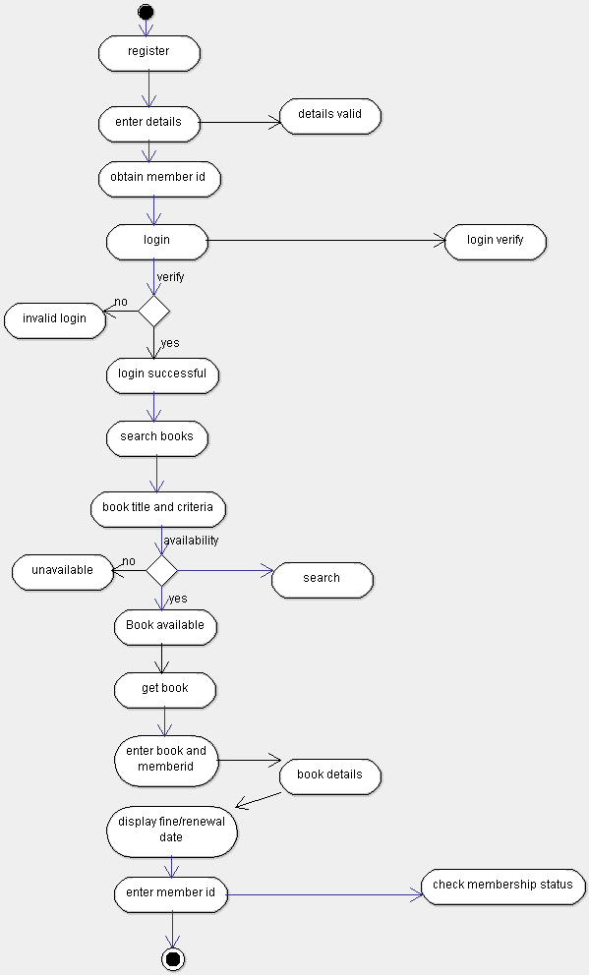

**STATE CHART DIAGRAM**

**Registration**



**Borrow**



**Return**



**COMPONENT DIAGRAM**



**DEPLOYMENT DIAGRAM**



**IMLEMENTATION AND TESTING:**

**Admin.java**

package Bookbank;

import java.util.Scanner;

import java.io.*;

class Admin extends Book

{

public void operation()

{

int a;

do

{

System.out.println("select an option");

System.out.println("1.Admin login\t2.Member login\t3.exit");

Scanner s=new Scanner(System.in);

int m=s.nextInt();

switch(m)

{

case 1:

{

Book p=new Book();

p.managebook();

break;

}

case 2:

{

Member c=new Member();

c.order();

break;

}

case 3:

System.exit(0);

}

System.out.println("enter 1 to continue to select login");

a=s.nextInt();

}while(a==1);

}

}

**Book.java**

package Bookbank;

import java.util.*;

import java.io.*;

class Book extends Member

{

int t;int f;int i=0;int count=0,count1=0;

public static int[] bid=new int[100];

public static String[] bname=new String[100];

public static int[] qty=new int[100];

public static int[] ord=new int[100];

public void managebook()

{

Scanner s=new Scanner(System.in);

do

{

System.out.println("1.Add\n 2.display\n 3.delete\n 4.update\n");

System.out.println("enter the option");

int n=s.nextInt();

switch(n)

{

case 1:

System.out.println("enter the number of Books to be added");

int no=s.nextInt();

System.out.println("enter the id,name,qty of the Book");

no=no-1;

int f=i+no;

for(;i<=f;i++)

{

bid[i]=s.nextInt();

bname[i]=s.next();

qty[i]=s.nextInt();

}

i=i;

System.out.println("Books added successfully");

break;

case 2:

System.out.println("enter the number of Books to be printed");

int scan=s.nextInt();

for(int i=0;i<scan;i++)

{

System.out.println("B_id B_name qty ");

System.out.println(bid[i]+"\t"+bname[i]+"\t"+qty[i]);

}

System.out.println("The Books informations are displayed");

break;

case 3:

System.out.println("enter the id of the Book to be deleted");

int did=s.nextInt();

for(int i=0;i<=bid.length-1;i++)

{

if(bid[i]!=0)

{

count++;

}

}

for(i=0;i<=count+1;i++)

{

if(bid[i]==did)

{

bid[i]=bid[count-1];

bname[i]=bname[count-1];

qty[i]=qty[count-1];

bid[count-1]=bid[bid.length-1];

bname[count-1]=bname[bname.length-1];

qty[count-1]=qty[qty.length-1];

break;

}

}

System.out.println("Boook is successfully deleted");

break;

case 4:

System.out.println("enter the id,name,qty of the Book to be added");

int nid=s.nextInt();

String nname=s.next();

int nqty=s.nextInt();

for(int i=0;i<=bid.length;i++)

{

if(bid[i]==nid)

{

bid[i]=nid;

bname[i]=nname;

qty[i]=nqty;

break;

}

}

System.out.println("Book is updated successfully");

break;

case 5:

System.exit(0);

}

System.out.println("enter 1 to continue to manage Books");

t=s.nextInt();

}while(t==1);

}

public static void main(String args[])

{

Admin sp=new Admin();

sp.operation();

}

public void delete(int n)

{

int did=n;

for(int i=0;i<=bid.length-1;i++)

{

if(i!=0)

{

count1++;

}

}

for(int i=0;i<=count1;i++)

{

if(bid[i]==did)

{

qty[i]=qty[count1];

break;

}

}

}

}

**Member.java**

package Bookbank;

import java.util.*;

import java.io.*;

class Member

{

public void order()

{

Scanner s=new Scanner(System.in);

Book p=new Book();

System.out.println("enter the Book id to be ordered");

int search=s.nextInt();

p.delete(search);

System.out.println("Book ordered successfully");

System.out.println("Enter 1to make payment");

int b=s.nextInt();

if(b==1)

{

Member c=new Member();

c.makepayment();

}

}

public void makepayment()

{

System.out.println("payment successfull");

}

}

**OUTPUT:**

Select an option

1. Admin login 2.Member login 3.exit

1

1.Add

2.display

3.delete

4.update

enter the option

1

enter the number of items to be added

3

enter the id, name, qty of the product to be added

1

HarryPotter

3

2

DaVinciCode

4

3

TheAlchimist

5

Items added successfully

enter 1 to continue to manage product

2

enter 1 to continue to select login

1

select an option

1. Admin login 2.Member login 3.exit

1

1.Add

2.display

3.delete

4.update

enter the option

2

enter the number of items to be printed

3

pid pname qty

1 HarryPotter 3

pid pname qty

2 DaVinciCode 4

pid pname qty

3 TheAlchimist 5

the product information is displayed

enter 1 to continue to manage product

1

1.Add

2.display

3.delete

4.update

enter the option

3

enter the id of the product to be deleted

1

product is successfully deleted

enter 1 to continue to manage product

1

1.Add

2.display

3.delete

4.update

enter the option

4

enter the id , name , qty of the product to be added

2

HarryPotter

2

product is updated successfully

enter 1 to continue to manage product

1

1.Add

2.display

3.delete

4.update

enter the option

2

enter the number of items to be printed

2

pid pname qty

3 TheAlchimist 5

pid pname qty

2 HarryPotter 2

the product information is displayed

enter 1 to continue to manage product

1

1.Add

2.display

3.delete

4.update

enter the option

1

enter the number of items to be added

1

enter the id , name , qty of the product to be added

1

DaVinciCode

6

items added successfully

enter 1 to continue to manage product

0

enter 1 to continue to select login

1

select an option

1.Admin login 2.Member login 3.exit

2

enter the product id to be ordered

1

item ordered successfully

enter 1to make payment

1

payment successfull

enter 1 to continue to select login

1

select an option

1.Admin login 2.Member login 3.exit

1

1.Add

2.display

3.delete

4.update

enter the option

2

enter the number of items to be printed

2

pid pname qty

1 DaVinciCode 0

pid pname qty

2 HarryPotter 2

the product information is displayed

enter 1 to continue to manage product

1

enter 1 to select login

select an option

1.Admin login 2.Member login 3.exit

3

Build successfull...

**TEST REPORT 1**

**Product : Book bank System**

**Use Case :manage book**

|  |  |  |  |  |
| --- | --- | --- | --- | --- |
| **Test Case ID** | **Test Case / Action To Perform** | **Expected Result** | **Actual Result** | **Pass/Fail** |
| 1. 1 | After Entering the Book id,name,qty | Displays ”Books added successfully” | Books added successfully | Pass |
|  | After Entering the Book ID to be deleted | Displays “book is successfully deleted”  ” | Book is successfully deleted | Pass |

**TEST REPORT 2**

**Product :Book Bank System**

**Use Case : manage book**

|  |  |  |  |  |
| --- | --- | --- | --- | --- |
| **Test Case ID** | **Test Case / Action To Perform** | **Expected Result** | **Actual Result** | **Pass/Fail** |
|  | After selecting “add” option | Displays “Enter the number of books to be added” | Enter the number of books to be added.  3 | Pass |
|  | After selecting “update” option | Displays “Enter the id,name,qty” of the book to be updated | Enter the id,name,qty of the book to be updated.  3  DaVinciCode  7 | Pass |

**TEST REPORT 3**

**Product :Book Bank System**

**Use Case :Make Payment**

|  |  |  |  |  |
| --- | --- | --- | --- | --- |
| **Test Case ID** | **Test Case / Action To Perform** | **Expected Result** | **Actual Result** | **Pass/Fail** |
|  | After books ordered successfully | Displays “Enter 1 to make payment” | Enter 1 to make payment | Pass |
|  | After Entering ‘1’ to make payment | Displays “Payment successful” | Payment successful | Pass |